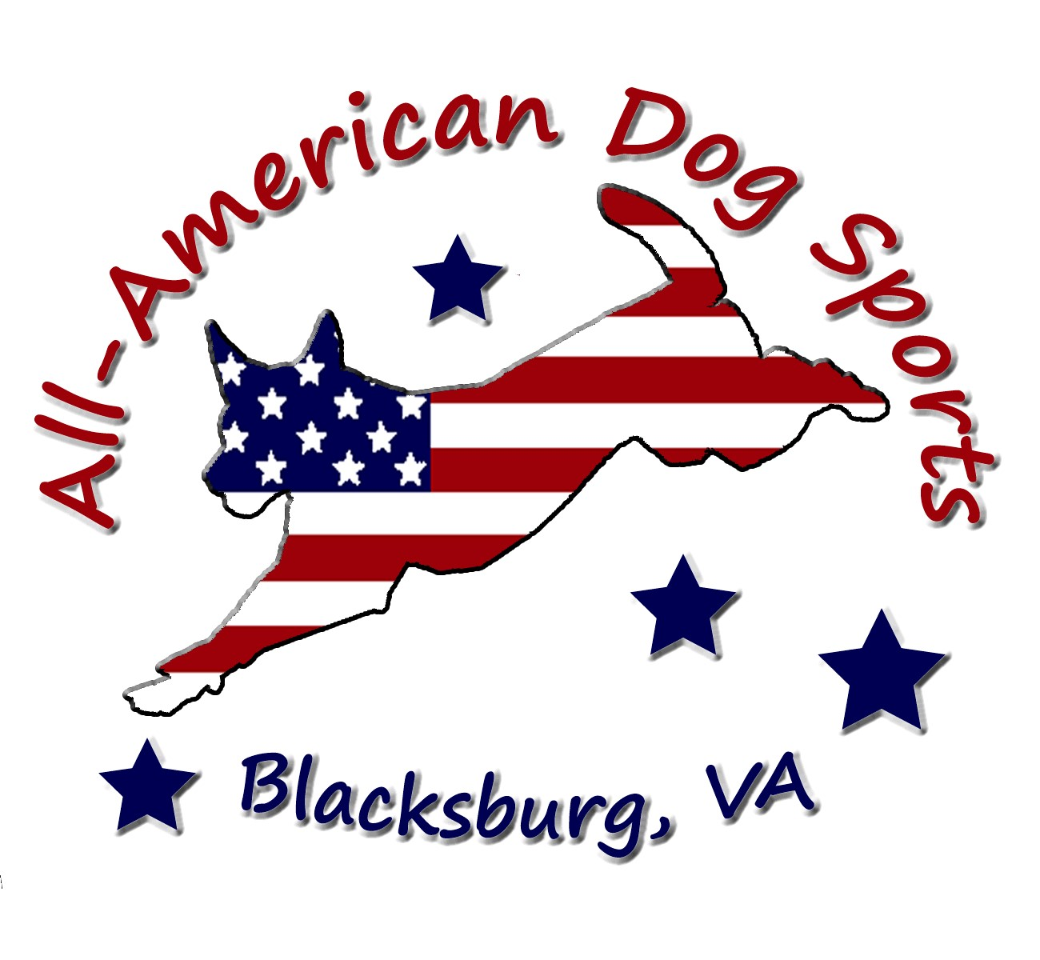
All-American Dog Sports  April 24-26, 2026  Blacksburg Town Park  725 Patrick Henry Dr  Blacksburg, VA 24060  Judge:  Karen Hough  Double Run Trial Format  Building and Ring Surface info:  Outdoors on Grass  Contact Surface:  Black rubber belting  Crating Set up times:  Friday after 1pm. (This is a public park – tents may be left at your own risk.)  Briefing at:  Friday at 2:45pm  Sat & Sunday at 7:45am  First dog on the line at:  Friday at 3:00pm  Sat & Sunday at 8:00am | Preliminary Class Order:  May change depending on weather, judges preference, time or number of entries  Friday  Saturday  Sunday
  Class: | Double Run | Single Run
  Grounders | 2
  Tunnelers | 2
  Class: | Double Run | Single Run
  Touch n Go | 2
  Regular | 2
  Weavers | 2
  Jumpers | 2
  Class: | Double Run | Single Run
  Regular | 2
  Chances | 2
  Tunnelers | 2

Entries Open on:  March 1, 2026  Entries Close on:  April 20, 2026  Crating available:  There is plenty of crating space around the ring. This is a public park, so personal items should not be left overnight. Tents may be left at your own risk.  Entry Limits:  400 Runs per day  Move ups:  Move-ups are allowed from day to day. If you finish a title and want to move up before the trial, email andrea@allamericandogsports.com by April 20, 2026  Day of show Entries:  We will accept day of trial entries if the trial does not fill. The day of show fees will be $15.00 per class with no packages  Refunds:  Refunds are allowed if requested before the  closing date. There will be no refunds for entries withdrawn after the closing date for any reason except bitches in heat. There will be no refunds in the event that a dog and/or handler are dismissed from competition regardless of reason for such dismissal. No entry fee will be refunded if the trial cannot open or be completed by reason of riots, civil disturbances, fire, an act of God, public emergency, act of a public enemy, or any other cause beyond the control of the  organizing committee. The organizing committee may refuse any entry as provided through NADAC rules and regulations. Anyone not in good standing with NADAC will not be allowed entry in  the trial.  *If you have tested positive for Covid or flu in the days leading up to the trial, please notify us and we will withdraw your entry and refund your entry fees* | Show Committee  Trial Chair:  • Cindy Lubin: cindy.lubin1@gmail.com  Trial Secretary:  • Andrea Lengi: andrea@allamericandogsports.com  Confirmations:  Preliminary confirmations will be sent within a week of receiving your entry. Final confirmations will be sent once the trial has closed. Please read over your confirmations carefully. We will be happy to make corrections if notified prior to the final move up date. If you do not receive a confirmation within a week of sending in your entry, please e-mail andrea@allamericandogsports.com.  Food info:  Snacks and water will be provided for workers. There are restaurants and grocery stores close to the park.  Volunteer info:  A Worker Sign Up board will be posted near the ring. Remember, the Worker Schedule must be filled out before each class can begin. Thank you in advance for the generous contribution of your time and energy!  Awards and Ribbons:  Ribbons will be awarded for 1st thru 4th place in each jump height (except Chances, which is pass/fail.) Qualifiers will receive a rosette. Anyone who achieves their NATCH at the trial will receive a special NATCH ribbon. Customizable New Title, New Award, and Debut rosettes are also available.  Special HIT Awards: This year we are also offering High in Trial rosettes based on total Q points (excluding Sunday’s tunnelers runs), for small (4-8”) Medium (12”) and Large (16-20”) dogs. We will also have an end-of-the-year High in Series customized award encompassing the April, October, and New Years trials.  Equipment info:  Rubber Surfaced A-Frame, Rubber Surfaced Dog Walk, Wingless Jumps, Open Tunnels, Hoops, 24” Spaced Weave Poles, and solid Barrels
Jump Height Info:

MEASURING
Measurement forms and more info may be obtained at:
www.nadac.com. Click on “Data Center”. Scroll down to “Permanent Height Card”.

All dogs 2 years of age and older are required to have a Permanent Height Card to compete.
(effective Jan.1, 2025)

JUMP HEIGHTS
There are four Standard Division-Proficient jump heights: 8”, 12”, 16”, and 20”.
There are four Standard Division-Skilled jump heights: 4”, 8”, 12”, and 16”.
There are four jump heights for the Veterans and Junior Handler divisions: 4”, 8”, 12”, and 16”.
Please see the NADAC Rulebook for the full jump height table

Brief Summary of Rules:
Please refer to www.nadac.com for a full explanation of all NADAC rules and up to date information.

- Please note that NADAC trials should provide a safe and fun environment for both exhibitors and their dogs.
- Aggressive dogs will not be tolerated and will be excused from the trial.
- The show committee has the right to refuse any entry. Anyone not currently in good standing with NADAC will not be allowed to enter this trial.
- Exhibitors, through submission of entry, acknowledge that they are knowledgeable of NADAC rules and regulations, and agree to abide by all rules in effect at the time of this trial.
- No entry fee will be refunded if the trial cannot open or be completed by reasons of riots, civil disturbances, fire, acts of God, public emergency, an act of a public enemy, or any other cause beyond the control of the organizing committee.
- Checks not honored by the bank do not constitute a valid entry fee. There will be a $25.00 service charge for bank returned checks.
- Dog must be registered and have a valid registration number before entries will be accepted. New Handlers please register here: NADAC-New Handler-Dog Registration. If you already have a dog registered with NADAC or are a NADAC Associate, please visit the H&D Portal to register a new dog.
- A copy of the current Exhibitors Handbook may be downloaded free from the NADAC web site: www.nadac.com
- Bitches in heat, lame, or blind dogs are ineligible for entry, as is any dog with a deformity which may cause a judge to not be able to reasonably assess the dog’s ability to function and perform agility obstacles safely, and in a manner that is in the best interest, health and welfare of the dog.
- No food, clickers, or other aids or devices shall be permitted on the course or within 10 feet of the ring. Food or a small non-audible toy can be in a secure container (zip-lock bag is acceptable) in your pocket during your run but you cannot indicate to the dog it is there. All handlers may bring a non-audible toy into the ring for training purposes. They cannot earn a Qualifying score and must declare to the judge they are training before they commence their run. Please read the Exhibitor’s Handbook for more information about toys and training in the ring.
- The sponsoring clubs will not be responsible for the loss or damage to any dog exhibited, or for the possessions of any exhibitor whether the result be accident or other cause. It is distinctly understood that every dog at this event is in the care and control of his owner or handler during the entire time the dog is on the show premises.

All-American Dog Sports April 24 - 26, 2026
Trial location: Blacksburg Town Park, 725 Patrick Henry Dr., Blacksburg, VA 24060
Make Checks Payable to: All-American Dog Sports
Send entries to: Andrea Lengi, 515 Farmingdale Lane, Blacksburg, VA 24060
Owner |  |  |  |  | Dog
Name |  |  |  |  | Call Name
Address |  |  |  |  | NADAC Reg #
City/State/Zip |  |  |  |  | Date of Birth
Phone |  |  |  |  | Height at Withers
Email |  |  |  |  | Breed
Handler, If not owner |  |  |  |  | Permanent Height Card on file with NADAC?  Yes No
Emergency Contact Name/Phone
CATEGORY: PROFICIENT SKILLED
DIVISION: STANDARD VET DOG VET HANDLER JUNIOR HANDLER
I WANT MY DOG TO JUMP: 4 8 12 16 20
Class | Level |  |  |  | Day
Class | Intro | Novice | Open | Elite | Friday | Saturday | Sunday
Regular |  |  |  |  |  | Rd 1 Rd 2 | Rd 1 Rd 2
Chances |  |  |  |  |  |  | Rd 1 Rd 2
Jumpers |  |  |  |  |  | Rd 1 Rd 2
Touch n Go |  |  |  |  |  | Rd 1 Rd 2
Tunnelers |  |  |  |  | Rd 1 Rd 2 |  | Rd 1 Rd 2
Weavers |  |  |  |  |  | Rd 1 Rd 2
Grounders |  |  |  |  | Rd 1 Rd 2
In consideration of the acceptance of this entry, I/we certify that I/we have knowledge of, and are familiar with, and agree to abide by, the Rules and Regulations of NADAC in effect at the time of this trial, and by any additional rules and regulations as approved by NADAC for this trial. I/we certify that the dog entered is not a hazard to persons or other dogs. I/we further agree to be bound by the “Agreement” printed on page 5 of this premium

Number of Total Runs Entered (all dogs): # ___________
□ 1 - 8 Runs = $13 each= ___________
□ 9 - 15 Runs = $12 each= ___________
□ 16 or more Runs = $11 each= ___________
□ Junior Handler = $6 each= ___________
□ Day of Show (after closing) $15 each =___________

TOTAL ENCLOSED =___________

Owner/Exhibitor: ____________________________________Date______________________
Parent or Legal Guardian of Junior Handler__________________________________________

AGREEMENT
The person who signs this agreement represents that he/she is authorized to enter into this agreement on
behalf of both exhibitor and the owner of entered dog. In consideration of acceptance of this entry:
1.1. As used here "NADAC" means the North American Dog Agility Council, LLC., its members, officers, directors, employees, show chairs, show committees and agents.
1.2. Exhibitor/owner agree to abide by the rules and regulations of NADAC and any other rules and
regulations appearing in the premium for this event.
1.3. Exhibitor/owner certify that the entered dog is not a hazard to persons, dogs or property and that
the entered dog's rabies vaccination is current in accordance with the requirement of the state in which the dog resides.
1.4. Exhibitor/owner acknowledge all hazards presented by the event and the event premises,
including, but not limited to, the condition of the surface, restrooms, security measures or lack of,
electrical appliances, fittings, show rings, parking areas and the presence of unfamiliar animals and
people; exhibitor and owner assume the risk of any harm arising from these.
1.5. Exhibitor/owner releases NADAC (including its respective officers, directors, employees, and
members), All-American Dog Sports (including its officers, directors, members, and event organizing
committee), and Town of Blacksburg Parks and Recreation (including its officers, agents, and employees) and will defend them and hold them harmless from all present and future loss, injury, damage, claims, demands and liabilities involving the entered dog, the event or event premises. Without limiting the generality of the foregoing, hold harmless provisions, exhibitor/owner hereby specifically assumes sole responsibility for and agrees to indemnify and save the aforementioned parties harmless from any and all loss and expenses (including legal fees) by reason of the liability imposed by law upon any of the aforementioned parties for damages because of bodily injuries, including death, at any time in consequence of my (our) participation in this event, howsoever such injury or death may be caused and whether or not the same may have been caused or may have been alleged to have been caused by negligence of the aforementioned parties or any of their employees or agents or any other persons

Run Pricing info (dogs within the same household):
1-8 runs = $13 each
9-15 runs = $12 each
16 or more runs = $11 each
Junior Handler runs = $6 each
Day of show entries will be $15 each

Lodging Info and Directions:
The motels have accepted dogs in the past. Please confirm pet policy and pet fees when you make your reservation. We ask your cooperation in cleaning up after your dogs in your room and on the motel grounds so that we can use these dog-friendly motels at future trials.
• Holiday Inn Express & Suites 1020 Plantation Rd, Blacksburg, VA 540-552-0900
• Hilton Garden Inn 900 Plantation Rd, Blacksburg, VA 540-552-5005
• Hyatt Place Blacksburg 650 University City Blvd, Blacksburg, VA 540-552-7500
• Residence Inn by Marriott 850 Prices Fork Rd, Blacksburg, VA 540-750-4400
• Hampton Inn, 380 Arbor Drive, Christiansburg, VA 540-381-5874
• Tru by Hilton 55 Hampton Blvd NE Christiansburg, VA 540-251-3604
• Comfort Inn, 3705 South Main Street, Blacksburg, VA 24060 540-951-1500
• Super 8, 55 Laurel St, Christiansburg, VA 24073 (540) 382-5813
• Quality Inn, 50 Hampton Blvd., Christiansburg, VA, 24073 (540) 382-2055

RV CAMPING AT TRIAL SITE
A limited amount of space is available for RV’s at the trial site. There are no hook ups or water available. Please contact Andrea Lengi by email at andrea@allamericandogsports.com - if you would like a spot reserved for you, and let her know the size of your RV.

DIRECTIONS TO TRIAL SITE
The trial will be held outdoors on grass at the Town of Blacksburg Park at 725 Patrick Henry Drive, Blacksburg, Va 24060. This is a public park, so please do not leave personal belongings at the site overnight.

From I-81 North or South, take Exit 118B and get on US460 West towards Blacksburg. (Exits 118 A, B, and C all exit together and split up later.) Drive approximately 10 miles (past Va Tech) and take the Tom’s Creek Road exit. Turn right onto Tom’s Creek Road. Drive 0.2 miles and turn left onto Patrick Henry Drive. Drive 1.3 miles, and turn right into the Blacksburg Community Center parking lot.

VETERINARIANS ON CALL
(These clinics have 24 hour emergency care. Directions available at the score tent.)
• Virginia-Maryland Regional College of Veterinary Medicine, Virginia Tech, Duck Pond Drive, Blacksburg, Virginia 24061, (540) 231-4621
• Town and Country Veterinary Clinic, 1605 N. Franklin St., Christiansburg, VA 24073, (540) 382-5042

